THE FLORIDA KEYS

The Florida Keys is a wonderful conglomerate of beautiful islands, ocean life, and a breath taking environment that will leave you coming back for more. Hours away from mainland and only 60 miles shy from Cuba, the Florida Keys is the perfect getaway destination for anyone who wants to get away to a quiet and peaceful place. A few things you can be sure to find in the keys involves gorgeous beaches, great food and drinks, lots of shopping, fun on the water, and much more.

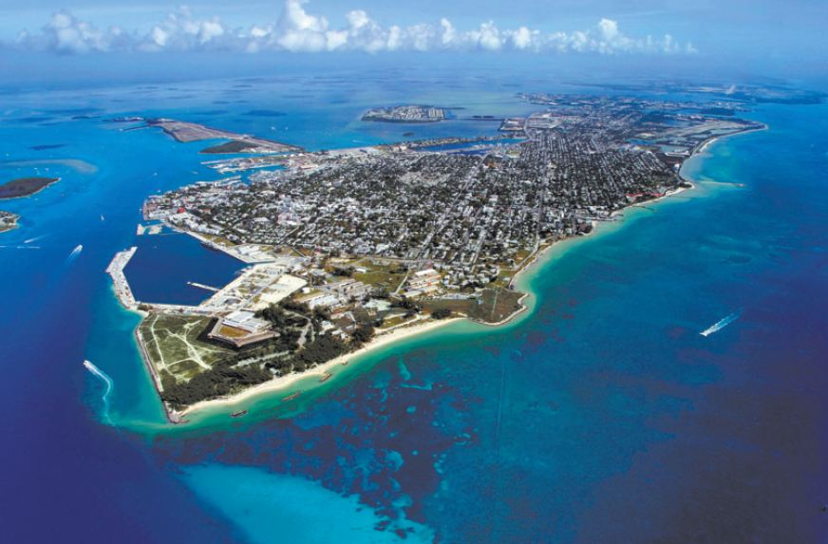

DOWNTOWN KEY WEST
A famous downtown commercial zoned street name duval that's only 1.25 miles long filled with so much fun things to do. Duval street represents the cultural ties to Cuba, many Cubans immigrated to the area in the late 1860s. Due to many cigar stores along the strip the city was named "Cigar City USA". Duval street is filled with many famous restaurants. The gulf shores of Duval Street often vibrate with a carnival like atmosphere that lasts until dawn and beyond. Duval street is somewhere to go that's full of life and more like a welcoming place to be. Tourist that come from ships shop along duval street at many different shops

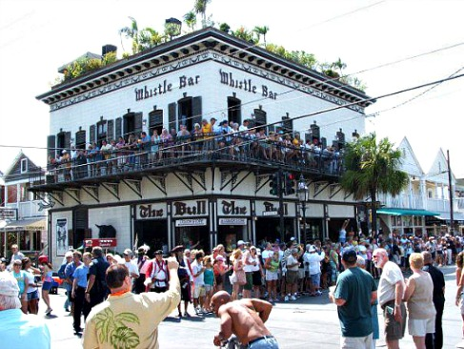

NIGHT LIFE
Those who are into night life, get ready to drink and dance the night away at any of the 100 bars located in downtown key west on the historic duval street. From the worlds smallest bar to the brand new senior frogs, there is the perfect mix of old and new key west to get anyone excited to grab a cocktail. With bars being open until 4am, you have enough time to make an unforgettable night.
Key West nightlife can be very eventful and a great new experience for everyone. There are many local bars and clubs to go to with you just want to relax. For example the very famous Garden of Eden which the only bar that Is optional about wearing clothes or not. Also if you go down Duval St you will find a strip of clubs and bars and all are very famous in the keys. One of the most famous and oldest is Ricks Bar. This the most popular part on Duval St and with the live entertainment good drinks you are bound to have a great time. When it comes to nightlife in Key West there will never be a shortage of bars clubs or most importantly ALCOHOL.

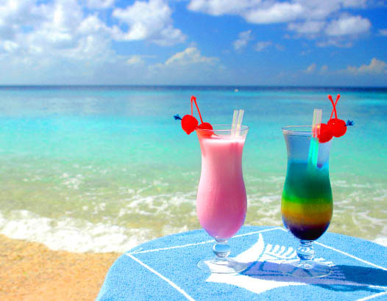

BEACHES
If you love swimming, snorkeling, sunbathing or fishing, then the waters of Key West must be something you explore when visiting. There are many beaches in Key West that visitors and locals love to visit. You have Fort Zachary Taylor, which is a state park with a pre-civil war fort. South Beach, which is a nice sandy beach with shallow waters and is a favorite. Rest Beach, which is a great beach for fishing and offers yoga classes at night. You also have Dogg beach and Higg’s Beach just to name a few.
Coming into the Florida Keys there is a large abundance of activities to do. Starting with the beautiful beaches and crystal clear water, take a dive in a sun bath on any of the keys white sand beaches. If you’re in for a more private beach there are also many resorts that provide private cabanas and catered food/drink.

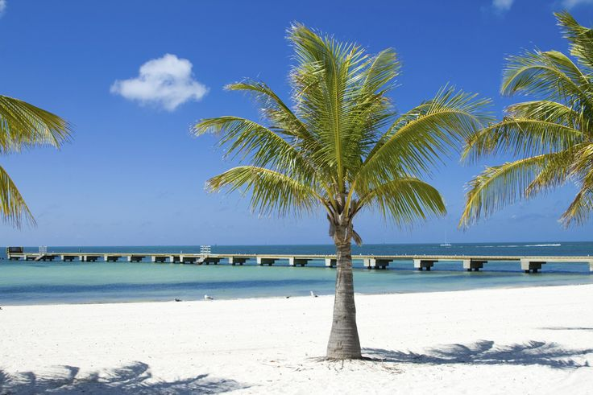

FOOD
Next best thing about the Florida Keys has to be the vast variety of food. Keeping true to the Florida Keys true traditions, it’s no surprise the food industry helps keep that same spirit alive. Being the diverse melting pot that it is, one can find an abundance of family run restaurants from Hispanic cuisine to European delights. And of course the most popular of those being the fresh local seafood. Experience amazing traditional food, with an amazing scenery, and find out why the Florida Keys is so well known for is Hospitality scene.
There are 10 delicious reasons you should be in Key West, Florida right now. The drinks and food are awesome. They have a drink called, a Rum Runner, it’s an Isla Morada cocktail creation. Surf and surf, there’s so much fresh seafood in Key West. Most of the living places are family owned, the hostility industry makes up most of the Florida Keys economy. Making the hostility in the keys are top notch. Also there are over 100 bars open all day and night.
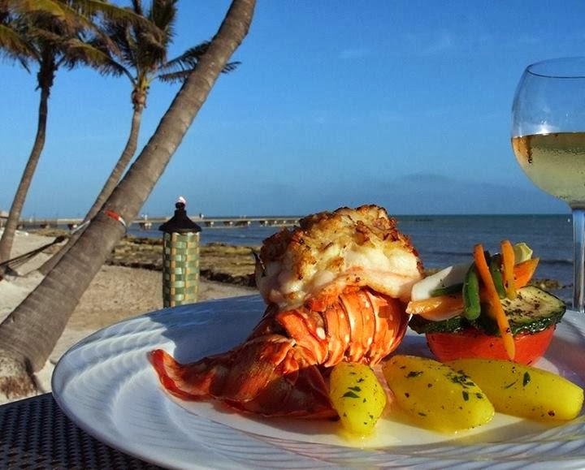

EXCURSIONS
Along with our beautiful beaches, for anyone who is adventurous enough to venture off into the immense waters, the Florida Keys offers many different sea excursions to really come face to face with some aquatic life. Fury Water adventures, a long running water sport company, offers many different activities. Take a day and go on the fury ultimate adventure trip where they start you off with a parasailing trip around the island getting a bird’s eye-view of the lush vegetation and immense ocean. After your soar through the sea hop on a jet ski and follow your guide as you embark on a ride around the southernmost part of the island, many people are known make a few dolphin friends along the way. After that put on your mask and snorkel as fury water adventure takes you on a snorkeling experience you won’t forget. Fury’s snorkeling spots are actually marine sanctuaries which are off limits to fishermen. So you really get to see the Great Barrier Reef in full bloom, full of gorgeous aquatic life and coral that stretches as far as the eye can see. After a long day of fun, it’s finally time to relax with a drink at hand as fury drives you around the island on a rum and reggae sunset drive. Which includes an all you can drink bar and live reggae music. Truly the ultimate water adventure trip is the epitome of what the Florida Keys waters are really about.

Excursions in Key West
- Air Excursions
- Key West Biplane Ride
- Soar above Key West in a biplane of the Conch Republic Air Force. See the Sand Key, buzz the lighthouse or see the sunset from the best seats in Key West.
- Price: $175.00 (15-18 minutes) Over the Island Tour
$299.00 (30-35 minutes) Island and Reef Tour
$349.00 (30-35 minutes) Sunset Flight
- Duration: 15-18 minutes OR 30-35 minutes
- Key West Parasailing Adventure
- Sailing 300 feet above the ocean, this excursion will take you over tropical reefs, schools of dolphins and fish and get a firsthand view of abended, wrecked ships.
- Price: 9AM ONLY - $35/ person
REGULAR - $42/person
- Duration: 1 hour
- Leisure Excursions
- Key West Beach Pass
- Soak up the sun on our luxurious beaches or participate in one of many activities included in your beach package. Kayak through the crystal clear waters, sail away on a hobie cat, or windsurfing are some of your many options.
- Price: $69/person
- Duration: Full Day
- Sunset Dinner Cruise
- Hop on our 65 foot catamaran and indulge in an all you can eat buffet. The buffet covers a full range of cuisine from Caribbean roasted pork to shrimp pasta salad and much more!
- Price: Adults - $59/person
Children - $39/person
- Duration: 2 hours
- Water Excursions
- Jet Ski Excursion
- A 26 mile, 2 hour Jet Ski tour around Key West and its neighboring islands. You will be stopping at historic landmarks such as the Southernmost Point, the Key West Harbor and the submarine pits.
- Price: 10AM - $99/person
OTHER - $135/person
- Duration: 2 hours
- Reef Snorkeling Adventure
- Take a beautiful catamaran to your snorkeling destination where you will descend beneath the crystal clear waters and experience sea life firsthand.
- Price: Adult - $45/person
Children - $25/person
- 3 hours

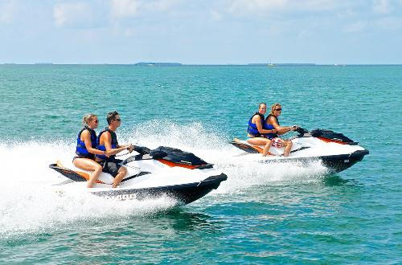
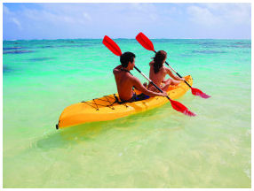
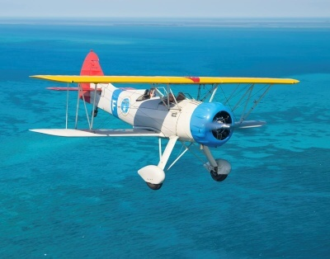

FISHING
What would a trip to the Florida Keys be without a little fishing expedition? Being known as the Flat fishing capital of America, you are guaranteed to have a boat load of fish on board without traveling no more than a few miles off land. Boats aren’t your thing? Well no worries, multiple piers and beache which allow for pool fishing can be found on all corners of the island. From delicious Hog fish and Grouper to huge sport fish like tarpon, the Florida Keys makes for the ultimate fishing getaway. Be sure to come by and fish like a local.

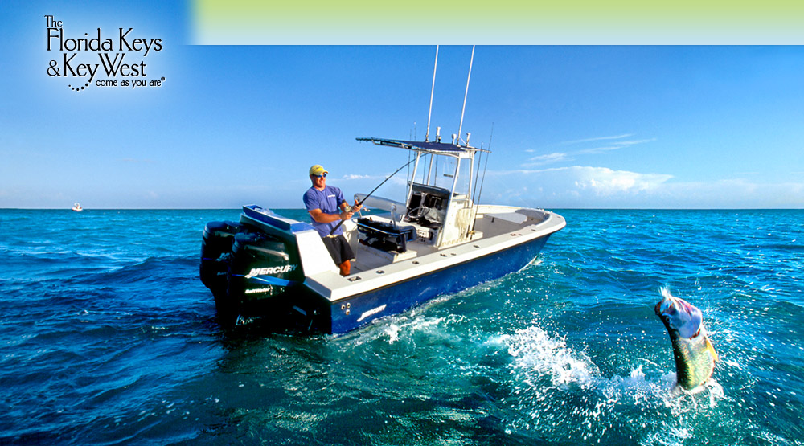

SHOPPING
The people at key west don't have shopping malls. But one of there popular surf shops is Ron Jon Surf. They sell a lot of of surfs, and t shirts, shorts, shoes, sun lotions , anything that is related beach. One of the popular place to buy key lime pie, and your food is Blue Heaven. What makes key west shopping so Eunice is the fact that it is not a town run off of franchise or corporate shops. Every store is family run and everyone sells something different and unique to the island. For example one may find home made conch shell, sea jewelry, and trinkets of all sorts. Making shopping in the Florida keys a very different and fun experience.

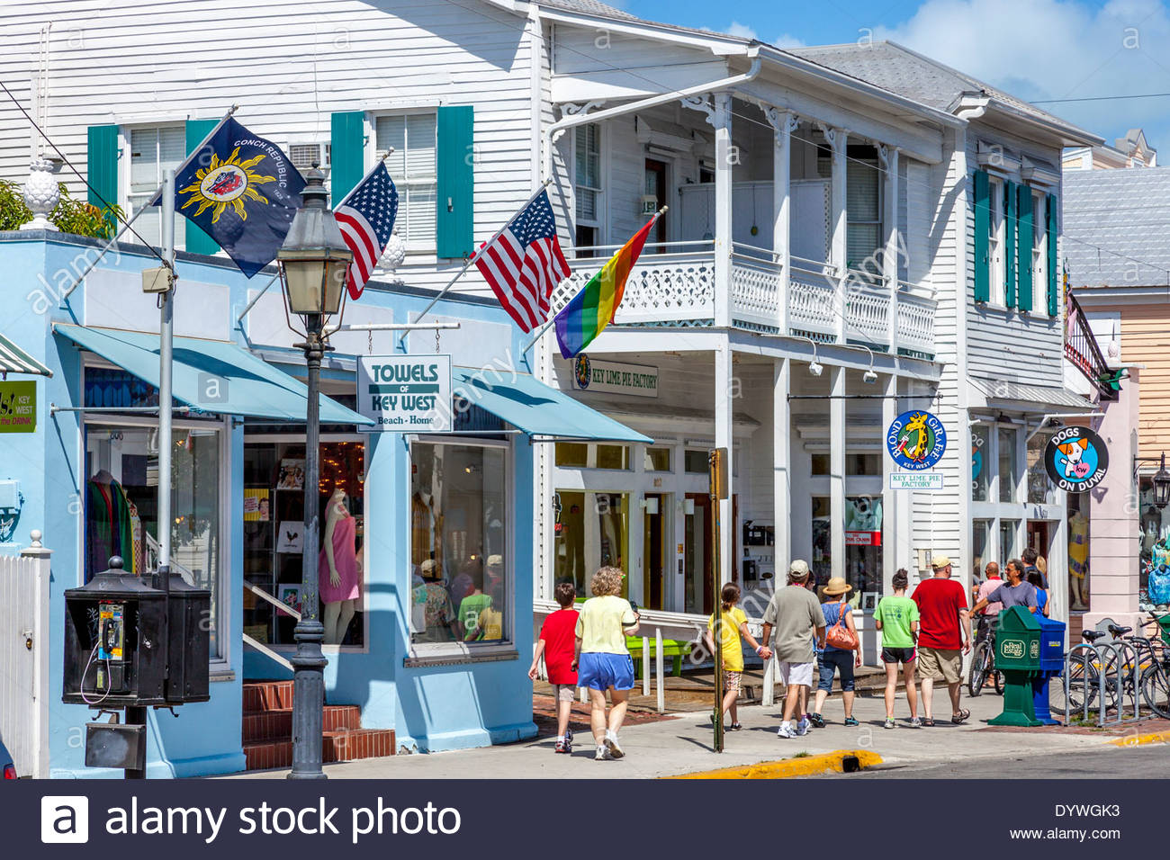

Travel & Accommodations
Flights
- Round Trip Travel Price: $369.20/person – Economy Class
- Departure from Tallahassee: Monday, September 19 – TLH -> EYW
- 7:00AM – Tallahassee, FL (TLH)
- 8:26AM – Miami, FL (MIA)
- 1h 13m Layover in Miami, FL
- 9:39AM – Miami, FL (MIA)
- Arrive in Key West at 10:35AM
- Departure from Key West: Monday, September 26 – EYW -> TLH
- 4:42PM – Key West, FL (EYW)
- 5:29PM – Miami, FL (MIA)
- 4h Layover in Miami, FL
- 9:29PM – Miami, FL (MIA)
- Arrive in Tallahassee, FL at 10:54PM
Accommodations
- The Gates Hotel I Key West
- Monday, September 19 – Monday, September 26
- Duration: 7 Nights
- Amenities: Outdoor Pool, Restaurant, Flat Screen TV, Refrigerator, En Suite Bathroom, Free Wifi
- 2.7 kilometers from Key West International Airport
- Price: $1,068 for all 7 nights

Between the food, shopping, fishing, nightlight life, and beaches, there is so much to do and for anything your heart may desire and in a beautifully tropical environment for just about anyone. But aside from the fun activity to be had, what truly gives the Florida Keys its charm is the Hospitality from the locals and that special nostalgic feeling of awe just being on the island. Truly a magical and interesting place to experience. Here in the Florida Keys come get away from your busy life, bring together your friends and family and come to celebrate. Not just for a special occasion but to embrace life for everything it is with the people who make your life that much better. Because that is the epiphany of the Florida Keys and what brought us to this island. Our famous motto, “every human is created equally from one human family” could never be more true.

Work cited

"Jet Ski Tours | Key West Water Tours." Key West Water Tours. Jet Ski Tours, 14 Apr. 2016. Web. 16 Sept. 2016.
"Air Excursions / Parasailing in Key West." Air Excursions. Excursions of Key West, n.d. Web. 16 Sept. 2016.
"Menu." Flights: Find Cheap Flights & Airfares. Priceline, n.d. Web. 16 Sept. 2016.

Sites Looked At
"The Top 10 Key West Tours - TripAdvisor." The Top 10 Key West Tours - TripAdvisor. TripAdvisor, n.d. Web. 16 Sept. 2016.
"Contact Us." Shore Excursions. Dream Cruise, n.d. Web. 16 Sept. 2016.
Conners, Valarie. "Key West Tours." Travel Channel. Key West Tours, n.d. Web. 16 Sept. 2016.
"KAYAK Mobile - Free IPhone, Android and BlackBerry Apps on KAYAK." Redirect. Kayak, n.d. Web. 16 Sept. 2016.

