Jonathan Monje
Professor Cirio
ENG 3416
Project 2 Remix Rationale
In our modern digital age, we are surrounded by an abundance of adaptations in both the tangible text form and that of media. We are over exposed to many works and pieces that claim to be original or “one of a kind”, but that could not be any farther from the truth. It is a fact that almost anything that is created, be that a thought or text in the rhetorical sense, is honestly deriving from some other piece of text, media, or simply an idea that was probably also a branch off from something else. This is considered a “Remix”, Edwards defines a remix as, “text that explicitly builds upon or repurposes already existing material” (Edwards p.42). Understanding how a remix works, one should take into account a few variables; which aspects of an original is carried or left out into the remix and why? What variables affect a remix be that audience, purpose, or genre? And how might a remix be circulated in a specific context? For further reference, we will be looking into and original text and two examples of its remix in both media and text form that I have created. Through these examples, and examples from rhetorical researchers, one can understand how a remix has become a very essential component in writing and under what context.
Before diving into the original text itself, one should keep the central question that this rationale will be revolving around being, “The relationship between a remix and how its circulated”. I found this to be an essential guiding question because the original text we will be dissecting is a recent video that had gained mainstream popularity within the digital world. Having millions of views on YouTube along with countless memes; understanding the relationship it has with the high circulation rate, will lead one to understand exactly how a remix works in the modern world. The reason for such popularity is because for one thing, the original text, in this case a video, had attracted a younger audience. Being that we have digital applications such as YouTube, Facebook, twitter etc. It was then sent around, hash tagged, retweeted, and remixed through different mediums. The video itself was filmed through 3rd person of young man who was acting very ignorant and idiotic. Using certain slang and slurs that many people found hysterical enough to share with their immediate friends and online communities.
Another important aspect of a remix one should analyze is how the construction of a remix is very similar to the idea of how text circulates. They both require an original thought or idea; much how Edbauer speaks on warner’s view of public circulation as having a need for preexisting forms and channels. “Sender-receiver models of public communication tend to identify a kind of homeostatic relationship, which simultaneously abstracts the operation of social links and circulation. The triangle of sender, receiver, text misses the concatenations that come to constitute Warner's version of a public.” (Edbauer p.3). In other words, for something to circulate, one must take in the original information, analyze and construct it subconsciously, then once it is shared again it holds some pieces of the original information along with a twist of the sender’s additional thoughts. The similarity between circulation and remix thus is a combination of the certain aspects from both the original piece and the remix that are either carried or taken away. In essence circulation and a remix individually have the same construction while also working cohesively.
Now that the connection between a remix and circulation is clear, we can move onto the first remix example being its digital form. Starting off we can agree that keeping a remix from digital form to digital form is one of its most popular remixed mediums. Its easy for people to correlate and make reference to. For my digital remix I used an application called “DubSmash”, which allows someone to take audio from a grossing meme, vine, or video and create their own video using that audio. Keeping the original audio in the remix also allows for a direct correlation from the viewers, being that the audio is the single most important variable in the original text. Then I recorded myself talking to my dog, the camera angle was shot directly behind my dog pointed towards me so the audience understood who was I was talking to. Because the original video was a young man arguing with someone about “having time to fight them”, I thought it would be funny for me arguing with my dog in the sense that I “have time to take him on a walk”. This brings me to the next important variable in the remix, certain lines that had become mainstream in the original were going to be my focus points in the remix. The most famous line in the original was the young man say, “Now I got time cuz”, this was refabricated many times through different memes and remixes. So having that single positions created the perfect blend of originality along with my new construction. Giving the video a different meaning yet holding onto the original videos popular point. Because there are a few variables within the remix being the use of DubSmash and the original audio, this can be considered as a assemblage, “Building a new text by compiling, aggregating, and juxtaposing a combination of already existing texts” (Edwards p.47)
Moving on we will discuss my remixed print. Having to create something that was tangible and circulated as such, I played off of a valentine’s day card which to me is one of the most circulated forms familiar with our culture across the scales, knowing no boundary of group or age. I kept a still image from the original text being the young man pointing his finger, which gave a direct correlation to the original allowing people to understand the theme. Placed it on a single page valentines day card with the following phrase: Roses are red, Violets are blue, Now I got time cuz, To love you!”. This was a very clever way to simultaneously and evenly distributer properties from the original text and a valentine’s day card. Along with a play on the classic roses are red poem. What’s interesting about this medium is that it was produced digitally so it could be circulated twice over not only tangibly by hand but also digitally. Allowing a wider audience between sender and receivers. This print remix calls on Edwards definition of Genre Play, “deploying a text that blends, repurposes, or moves in and out of genre expectations” (Edwards pg.50).
Understanding a remix in the rhetorical sense, one comes to realize how basically all aspects of ideas, genres, media, etc. are all fabricated through the idea of a remix. To say someone is original really doesn’t hold its own anymore. Such as circulation of ideas is merely taking an original thought and forming your own, media and text are also reconstructions of something someone has already done or thought of one way or the other. But that is why a remix is such a crucial component in writing, because it is writing in the same sense. It is merely regurgitated thoughts that form new ones, ideas that spark one another. It is a building block to create new things, though not entirely new. Without inspiration or a starting point, it would be impossible for ideas to form.
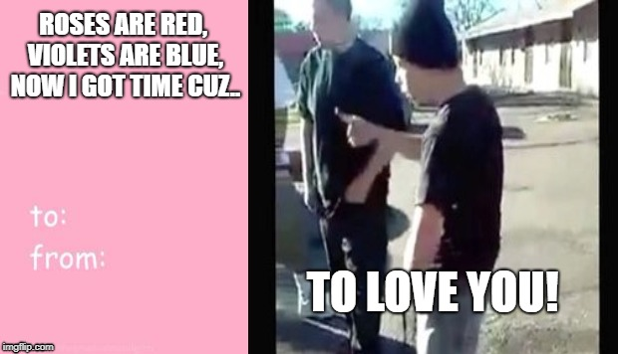

Work Cited
Jenny Edbauer (2009) Unframing models of public distribution: From rhetorical situation to rhetorical ecologies, Rhetoric Society Quarterly, 35:4, 5-24, DOI: 10.1080/02773940509391320 (Edbauer)

Dustin W. Edwards (2016) Computers and Composition, ISSN: 8755-4615, Vol: 39, Page: 41-54
Publication Year: 2016 (Edwards)

