“Gulf Specimen Marine Laboratory’s mission is to further through study, research, publication, teaching and public display the knowledge of marine biology; to promote protection of marine life and the marine environment; to collect, classify and disseminate marine biological specimens.” - GSML
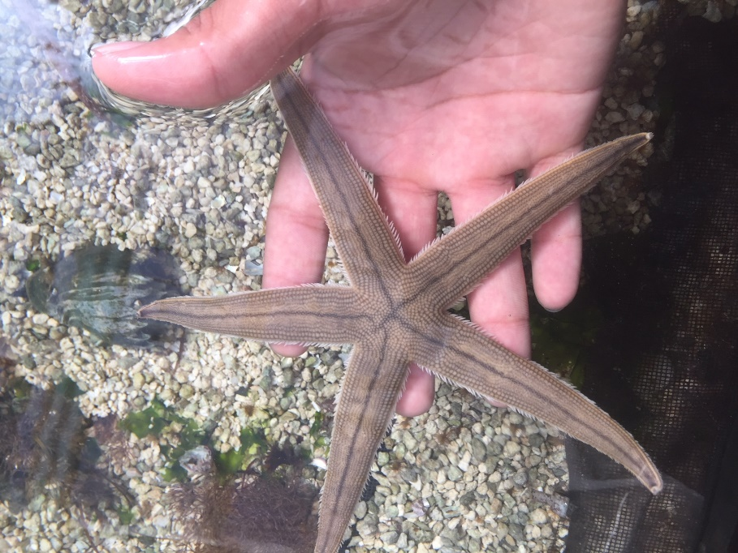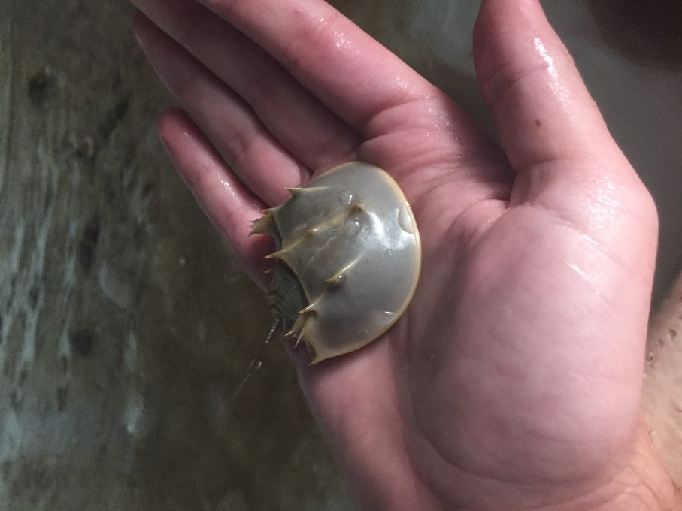
(Starfish) (Horseshoe crab)
Within gulf specimens 8,500 square feet of interior exhibition and program space, they provide guests with the chance to not only view the different assortment of marine life found within the facility, but they also allow you to pick up and touch certain aquatic life. Pictured above we can see a starfish and horseshoe crab, two specimen which you are allowed to pick up and touch.
It is important to understand that certain tanks and salt water ponds are excluded only to touch while most are simply to just observe. Through the process of being able to interact with these creatures, Gulf Specimen Lab. Is creating awareness to these creatures, igniting a spark of curiosity which pushes the guest to become more familiar with some of the creatures we have here in Florida’s ecosystem.

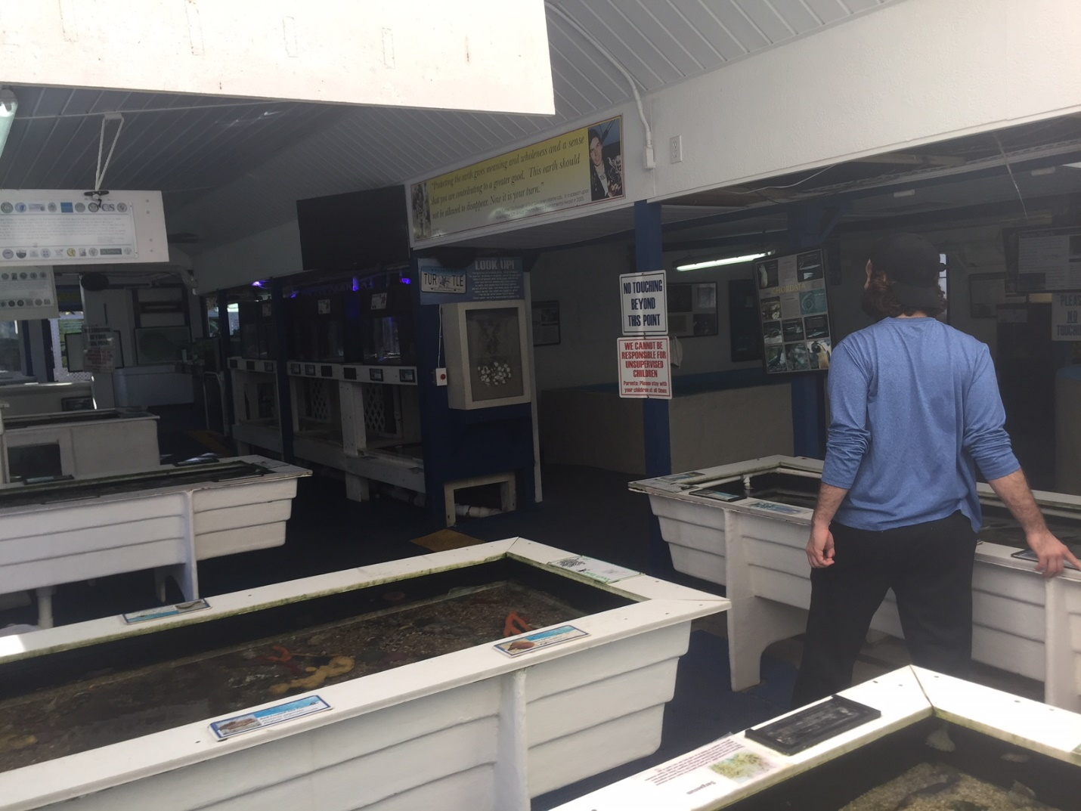
(first interior room)
This photo shows the interior to the first room you walk into upon entering the marine displays. Each one of the individual salt water ponds holds a variety of aquatic life, each separated into different species and organisms.
While walking around, one can find a pond that holds lush amounts of sea snails, starfish, flounder, clams, and even simply shells. Displayed around the boarders of the ponds the Marine Lab has provided information pertaining the creatures found in each enclosures, along with signs stating weather or not the guest are allowed to touch and pick up.
“our touch tanks, graphic exhibits and conducting field trips to provide a unique “hands-on” experience enabling students to touch, smell, and hear the odd and interesting creatures of the Gulf of Mexico, and develop an awareness and desire to protect the fragile life in the sea.” -GSML
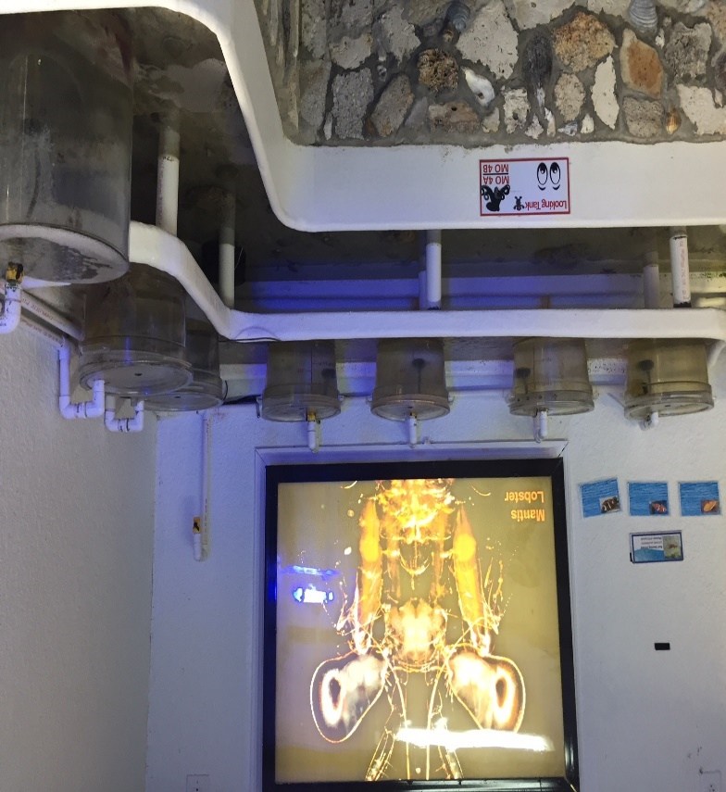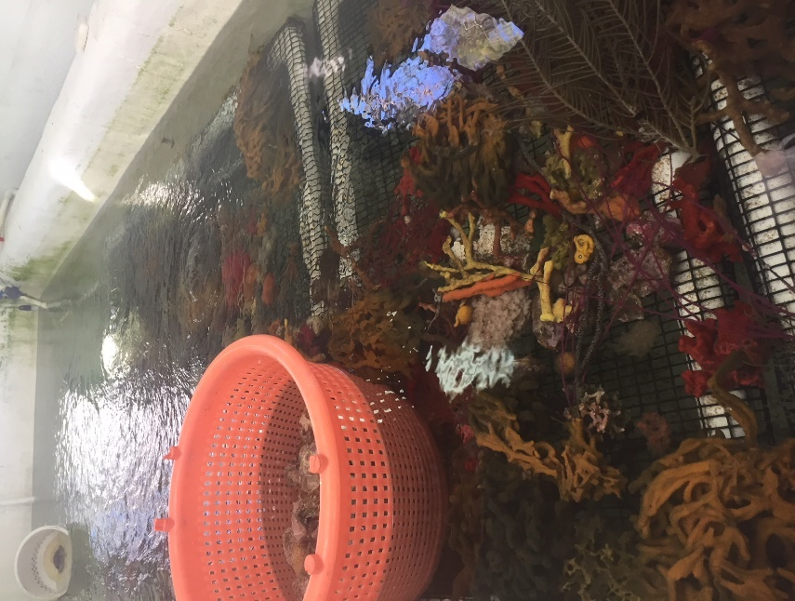
(Shrimp farm) (coral enclosure)

Along with holding a verity of fish or organisms, the Marine Labs also allow guest to view what the organization does in terms of aquatic farming and recovery. Pictured above is a shrimp and coral farm which is also located within the viewing areas for guest to see. While examining these tanks, one can see the labor that goes into gathering and keeping these organisms alive while also being able to appreciate the beauty behind these organisms. These enclosures themselves were of well size, with very extensive and intricate water filtration system, these farms showcase the impressive and tedious work researchers conduct.
The researchers here at Gulf Specimen run a copious amount of testing on marine life which include ways to preserve certain species of fish and coral. Examining the coral enclosures, one can find numerous and colorful corals and rocks which have been captured in the wild and placed here in the Lab for testing and researching.
“We also study endangered species and conduct research in maricultural, farming the edge of the sea.” -GSML
(Blue crabs) (Sting ray)
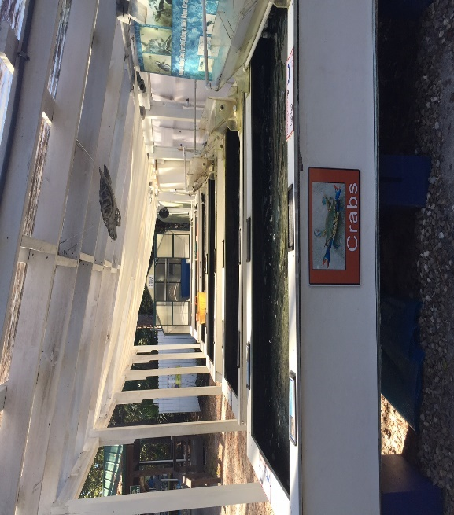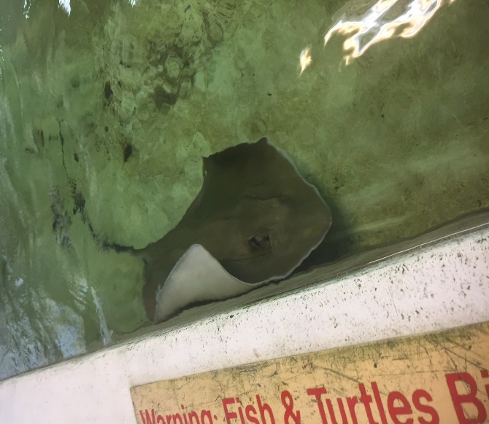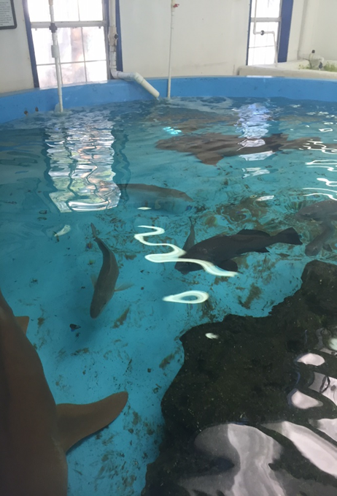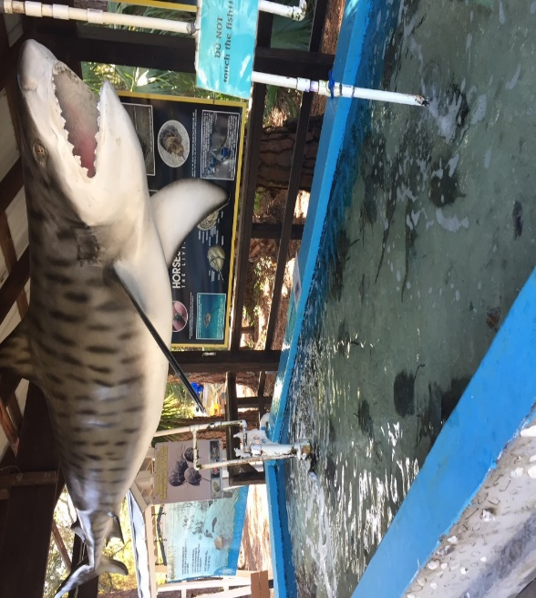
(Nurse sharks) (Horse shoe crabs)
One of the coolest aspects to the captivity of the marine life located here at Gulf Specimen is the interaction one can find with the different species. It became very apparent to me how well the animals are taken care of and handled here, compared to other zoo’s and aquariums that I have visited before. While walking past the Sting ray tank (top right), I noticed how un-phased the Sting ray was to my presence. He kept very calm nature even when I approached him directly, he even seemed to swim right up to me, flapping his rear fin right at me. The same goes for most of the Horseshoe crabs (bottom right) also the nurse shark tank (bottom left). All these creatures seemed like they wanted you to touch them, I have never seem aquatic life act so calm and welcoming before in my entire life.
It really speaks on the relationship the researchers and handlers have at Gulf Specimen. Its obvious that they genuinely care for their animals, and expect the same for the visitors that come.
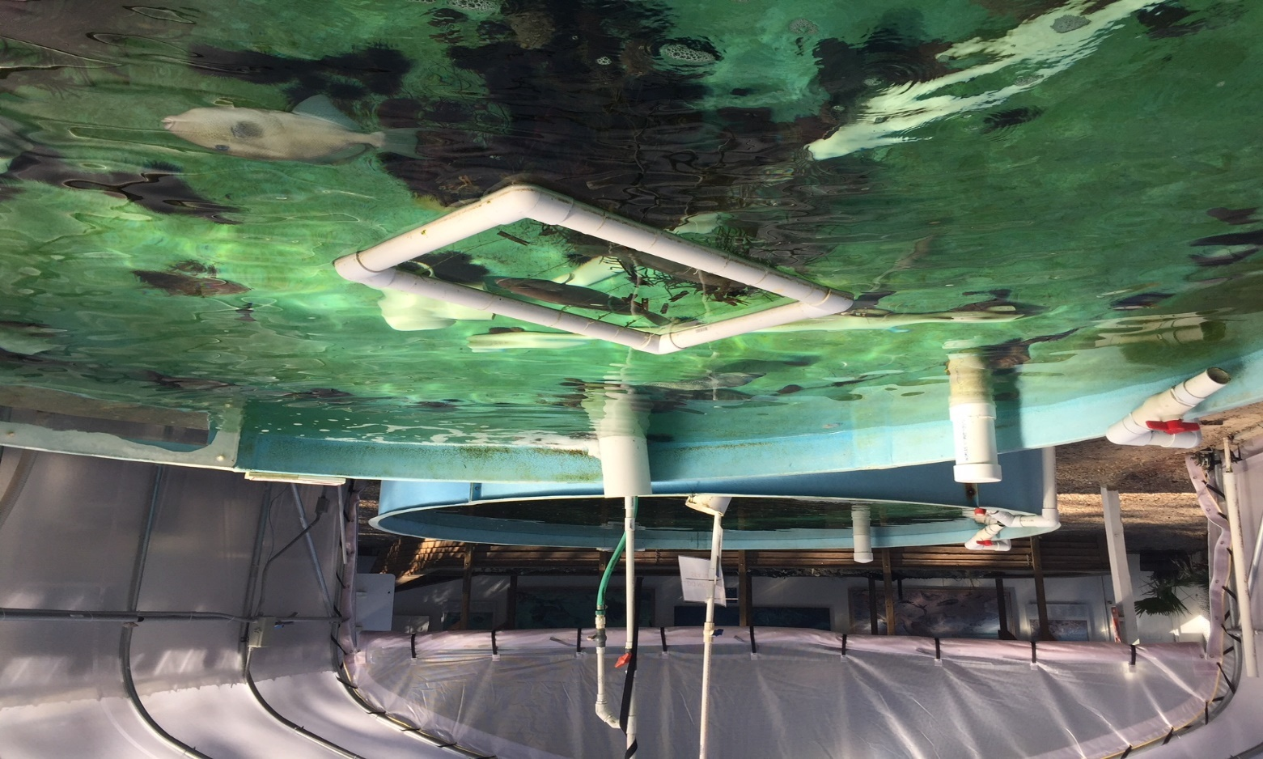
(outside Sea Turtle tank)

Gulf Specimen being known for their rehabilitation projects house some aquatic life which they are working with to better understand in hopes for future education on prolonging life and just being able to enhance the general understanding for some of the creatures one can find in Florida’s ecosystem.
Pictured above is a pond located in the outside portion of the Marine Lab which actually houses a blind sea turtle named “Lil’ Herc”. Lil’ Herc is a loggerhead sea turtle who was injured in a boating accident and blinded. She has been in captivity for going on 20 years previously taken from Sea World.

“In addition to working with children and rehabilitating wounded or sick sea turtles, we work closely with biomedical institutions studying the ocean’s vast storehouse for sources of potential new pharmaceuticals and have become an integral part of numerous research programs all over the United States, Canada and Europe” -GSML
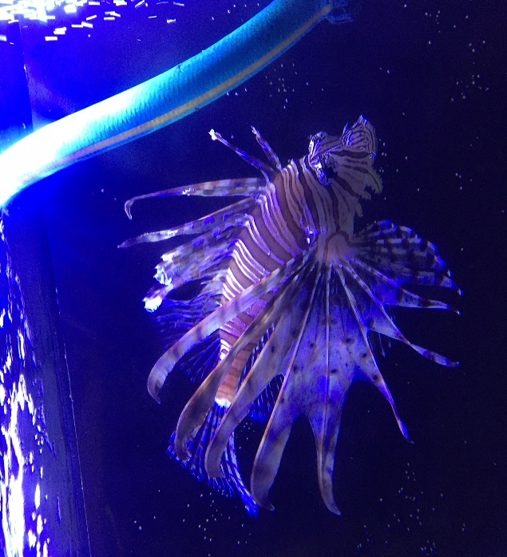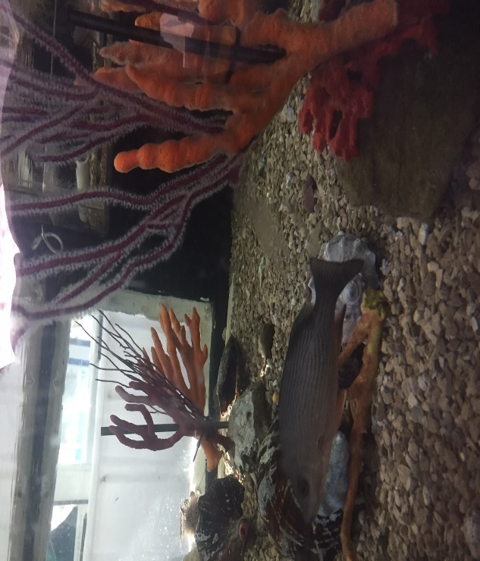
(Lion fish) (snapper)

Throughout the exhibits, it is apparent to tremendous amount of fish that one can find within Gulf Specimen. Taken from two different tanks in the pictures above, we find the extremely invasive species known as the Lion fish, and a species of fish which is found in large abundance the grey snapper.
What is interesting about the Lion fish is that they have become a very prominent problem within Florida’s waters within the recent years. Their presence has been hurting our reefs and the natural order of the Florida ecosystem in general. It is no surprise to find one in the hands of Gulf Specimen, researching these creatures can help us understand why they might have appeared in great numbers in the recent years and shed light into the biology behind the Lion fish and their behavior.
Another interesting fact about Gulf Specimen is that they routinely have different species of aquatic life which rotate in and out of the facility, which only adds to the various research to be conducted, and the different species one can find while walking around in inspecting the different areas.
“Our exhibits are never the same twice. The marine biological supply operation that supports the laboratory provides a constant flow of animals coming through the lab.” -GSML

